ELEGANT Adults only hotel (16+)
A place of relaxation with attentive service!
Right on the promenade having superb location in the first line of Golden Sands, it is a deluxe hotel in a tranquil atmosphere for exquisite guests. The hotel offers accommodation with modern design and breathtaking view to the Black Sea.
GRIFID Metropol is a premium product that has been part of the GRIFID Hotels family since 2013. It offers bespoke service and a warm, welcoming atmosphere.

Highlights and new services
- Free Special - Direct Transfer - Varna Airport-hotel/hotel - Varna Airport (upon request)
- A la carte service in all outlets to enjoy the full pleasure of holiday time!
The hotel offers waiter service also at the infinity pool and on the beach, on the deck chairs, with refreshing drinks and fruits.
- Selection of quality branded Bulgarian and International wines in all restaurants
- Stay 4 nights or more and enjoy the Premium DINE Around program free of charge.
A great variety of culinary delights with the GRIFID DINE Around program: Molecular Cuisine, Fish and Rodizio, Italian, Bulgarian, Asian and European cuisine at Hotel Vistamar, Bolero and Metropol (16+). An additional highlight of the program is the Sky restaurant in Vistamar (1*stay).
Advance reservation is required for all a la carte dinners
- Pool bar at infinity pool offers tasteful smoothies, fruits infused water and our NEW cold coffees and milkshakes menu
- Sky Bar with breathtaking panoramic view
- The hotel has its own fine sandy beach, separated only by the promenade. One beach umbrella and two sunbeds (with mattresses) per room (subject to availability) and a lounge beach bar
- Beach cabanas - reservation required and with surcharge
- Free access to the professional panoramic gym with a breathtaking view of the sea horizon at the Hotel GRIFID Encanto Beach. (7 min. walk away) from 06:00 - 21:00h
- Healthy line in all restaurant menus
- Bio swimming pool with a natural pebble bottom, artificial beach and natural surrounding
- Professional evening entertaining program
- Theme parties (BBQ evenings and beach parties; July - August)
- NEW: in-room amenities for comfortable stay: next to quality branded bath amenities “RITUALS” and the welcome gift, a new service: Fitness Kit upon request is at the disposal of all guests
- Romantic Dinner at the beach in front of the hotel - reservation required and with surcharge
- Certificated by Travelife
- Program for guests with allergies: special menus for the most common food allergies (on request and after prior notification at the time of booking

General information

- PREMIUM All Inclusive basis, Adults only hotel (16+)
- one main 11-storey building
- Located on first line in Golden Sands resort
- 15 km from Varna
- 30 km from Varna Airport
- 500 m from the center of the resort
- 50 m from the shopping center
- 500 m from a public bus station
- Languages spoken: Bulgarian, English, German, French, Russian
- 24-hours reception & 24 hours security
- GRIFID Concierge service - taking care of all little details that matter for your stay
- Main restaurant (for breakfast and dinner), “Prego” a-la-carte restaurant (for continental breakfast, lunch, afternoon snack and theme dinner: Mediterranean cuisine, Bulgarian, Rodizio & Italian), Premium Dine Around Program
- Lobby/Piano bar, Pool bar, Sky bar offer variety of local and international alcoholic and non-alcoholic beverages, Lounge bar at the beach - selection of local alcoholic and non-alcoholic beverages
- Facilities in public areas are wheelchair accessible (except for the beach location)
- Parking - limited and against charge
- GRIFID Souvenir Shop
- Free Wi-Fi connection in hotel lobby area and in the rooms
- Taxi & Rent-a-car services
- Laundry and ironing service - at a charge
- Currency exchange
- Doctor
- Gym, Wellness & Relax center
- Certificated by Travelife

Accommodation
- Check-in time - from 15:00h - starts with afternoon snack menu
- Check-out time - until 11:00h - ends with late continental breakfast
- 136 hotel rooms with sea side view or direct sea view, Junior suites with sea/side sea view, apartments with sea view
- All bathrooms are with bathtub with shower in it (in Junior suites and apartments there is a separate shower)
- Hairdryer & Cosmetic mirror
- International dialing phone
- Central air conditioning system
- Satellite TV
- Free Wi-Fi connection
- In-room safe - free of charge
- Mini bar - free of charge, daily restocked (water, soft drinks incl. soda, beer)
- Coffee machine with capsules in all rooms
- Balcony
- Rooms with wall-to-wall carpet or laminated floor
- Quality branded bath amenities - “RITUALS”
- Pillow menu
- Fitness Kit (upon request)
- Top mattress menu - upon request
Early check-in and late check-out depend on the availability of the hotel and are subject to additional payment.

Restaurants
Part of Premium All Inclusive basis
MAIN RESTAURANT
Spacious hall with belonging open-air terrace overlooking the bio swimming pool.
Breakfast 07:30 - 10:00
Dinner 18:00 - 21:30

- A la carte service
- Breakfast served in combination of cold buffet for cold cuts, cereals etc. with a la carte menu and table service for hot dishes such as omelets, pancakes, eggs, etc.
- Included drinks for breakfast - freshly pressed orange juice, smoothies, water, coffee, tea
- Dinner is a combination of buffet for salads, starters and desserts and a la carte menu
- Included drinks for dinner - water, juice, soft drinks, draft beer, selection of quality branded International and Bulgarian wine
- Gala dinner - once in 10 days
- Smoking indoor is not allowed
Dress code for dinner: Smart Casual: shorts are permitted except swimming trunks, beach attire, flip flops and sleeveless shirts.

“PREGO” A LA CARTE RESTAURANT
Continental breakfast 10:00 - 12:00 a la carte service
Lunch 12:00 - 14:00 a la carte service
Afternoon snack 14:00 - 17:00 a la carte service
Dinner 18:30 - 21:30 a la carte service

- Lunch with daily menu and buffet for salads and fruits
- Afternoon snack: pizza, pasta, salads, desserts, ice cream
- Theme evenings: Mediterranean cuisine, Bulgarian, Rodizio & Italian - reservation in advance required
- Included drinks - water, juice, soft drinks, draft beer, selection of quality branded International and Bulgarian wine
- No smoking indoors
- Тhematic a la carte dinner is Included with minimum stay required
Dress code for dinner: Smart Casual: shorts are permitted except swimming trunks, beach attire, flip flops and sleeveless shirts.

FUSION A LA CARTE RESTAURANT

Discover the delights of molecular cuisine in an elegant setting with a 9-course tasting menu!
18:30 - 22:00 a la carte service
- Reservation in advance required
Dress code for dinner: Smart Casual: shorts are permitted except swimming trunks, beach attire, flip flops and sleeveless shirts.

PREMIUM DINE AROUND PROGRAM
Valid for stays of at least 4 nights
Premium DINE Around program with exclusive offer for a dinner in the Sky a la carte “Pagur” in hotel Vistamar (once per stay), as well a diverse and complimentary choice of a la carte restaurants with variety of cuisine types for our guests: Prego in Metropol with theme evenings (Italian, Bulgarian, Rodizio and Mediterranean), molecular cuisine in Fusion restaurant, Fish in Bolero and in Vistamar – European and Asian cuisine
For all restaurants part of “Dine Around” program advance reservations are required.

Bars
Bars - part of Premium All Inclusive basis
LOBBY - PIANO BAR
Drinks 15:00 - 24:00
GRIFID homemade cookies and cakes, coffee, tea 15:00 - 17:00
- PREMIUM All Inclusive offer features local and imported alcoholic and non-alcoholic beverages, refreshing cocktails, coffee and tea, draft beer and local wine and selection of quality branded International and Bulgarian wine
- Live music evenings and entertainment (professional musicians and dancers)
- A la carte service
- Afternoon pastry offer (variety of homemade cakes, cookies and tartlets)

POOL BAR
Drinks 10:00 - 17:00
- PREMIUM All Inclusive offer features local and imported alcoholic drinks, draft beer, non-alcoholic beverages, refreshing cocktails, tasteful smoothies and fruits infused water, coffee and tea, cold coffee drinks and milk shakes.
- Bar service

SKY BAR on 12th floor of the hotel
with breathtaking panoramic view complements the experience of our guests with innovative cocktails
Drinks 20:00 - 24:00
LOUNGE BEACH BAR
10:00 - 17:00
In high season: 09:00 - 18:00
- Mineral water, local alcoholic and non-alcoholic beverages, refreshing cocktails, coffee and tea, draft beer and local wine
- Bar service
- Special snacks selection at the beach bar between 11:30-17:00 o’clock
- Fresh fruits are served to the sun chairs in the afternoon

Swimming pools and Wellness center

OUTDOOR POOL WITH INFINITY EFFECT
09:00 - 18:00

- Sun terrace by the pool
- Complimentary sun lounges, parasols, pool towels
- Life guard service provided
OUTDOOR BIO POOL WITH PEBBLE BOTTOM
09:00 - 18:00

- Artificial beach with sun terrace by the pool
- Natural surrounding
- Complimentary sun lounges, parasols, pool towels
- Life guard service provided
Beach services included
One parasol and two sun beds per room on the beach in front of the hotel upon availability (only for full paying customers)!

Wellness and Relax
Services - Massage room, Sauna, Beauty salon, Relax zone
09:00 - 18:00
All treatments: massages, sauna and Beauty salon are additionally charged!
- Sauna
- Relax zone
- Hairdresser, manicure and pedicure
- Massage rooms; facial and body treatments and range of spa treatments

EXCLUSIVE OFFER for all guest of Metropol: free access to the professional panoramic gym with a breathtaking view of the sea horizon at the Hotel GRIFID Encanto Beach. (7 min. walk away) from 06:00 - 21:00h

SPORT & Activities

- Small fitness room with air conditioning in hotel Metropol
- Professional equipped with Technogym Fitness Studio at Encanto MediSPA (06:00-20:00), in a distance of 7 min. walk on the promenade
- Boccia
- Yoga
- Bicycle tours
- Well-fit zone - with Step Aerobics, Gymnastics
- Water Gymnastics
- Multifunctional playground at GRIFID Club Hotel Bolero - for football, basketball, volleyball, tennis court and tennis rackets - free of charge; reservation required

ROOMS

Double room with sea side view or frontal sea view - 2+0. Appr. 23 m2
Junior suite with sea and side sea view - 2+0, 3+0. Appr. 38 m2.
Apartment with sea view - 2+0, 3+0. Appr. 55 m2.

EXTRA Paid Services

- Parking lot - limited
- Rent a car
- Spa treatments in wellness center
- Services in Beauty salon
- Wine List with special selection – at extra charge
- Bicycle (when not part of the animation bicycle tour)

Miscellaneous

Pets are not allowed.
Hotel reserves the right to change opening hours of the outlets, if necessary.
Under Bulgarian legislation it is not allowed to smoke in the hotel lobby, restaurant, bars and rooms (indoors).
Sun bed reservation is not accepted. Any unattended towels are removed from the pool and beach staff.
Food and beverages cannot be taken out of the restaurants due to Public and HACCP regulations.

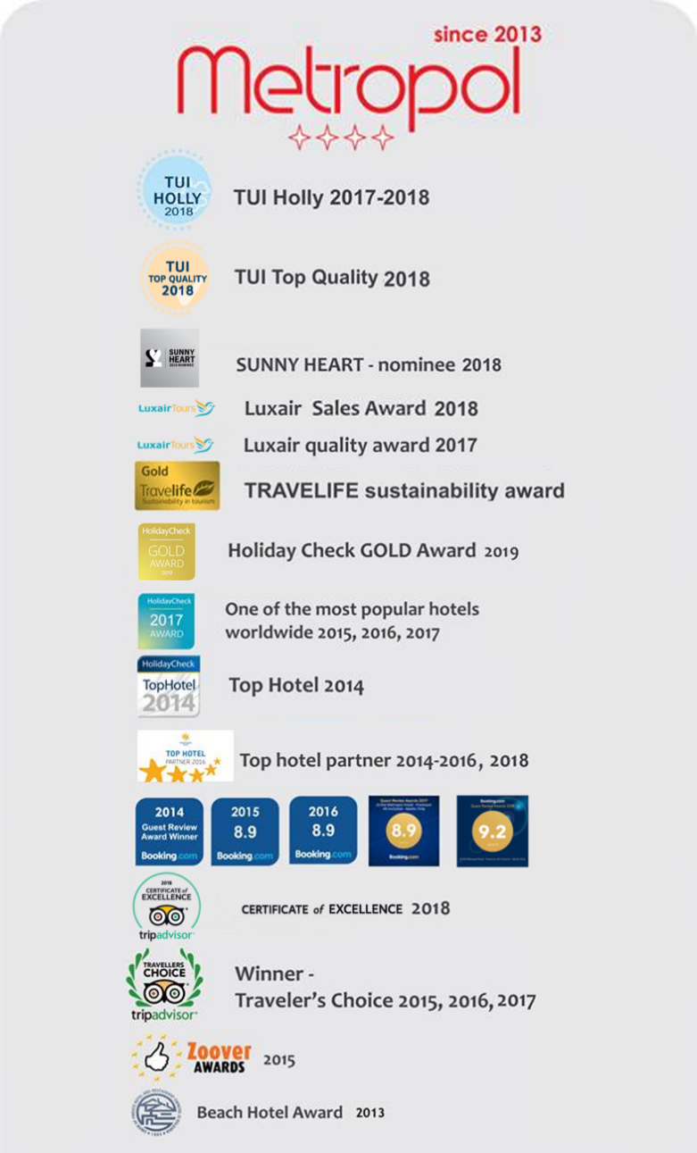
Contacts

Tel.: +359 887 47 43 43 (Hotel Reception)
WEBSITE
www.grifidhotels.com
PHOTOS AVAILABLE AT
https://grifidmetropol.pixieset.com/grifidhotelmetropol/
AWARDS

